VISITING PROFESSORS OF THE FIRST FACULTY OF MEDICINE,
CHARLES UNIVERSITY
Visiting Professor
Prof. Paul E. Mozdiak, PhD

Visiting Professor Home Institution
Professor, Prestage Department of Poultry Science, North Carolina State University

Director, Interdisciplinary Physiology Graduate Program, North Carolina State University
Unit of the 1st Faculty of Medicine
Institute of Anatomy

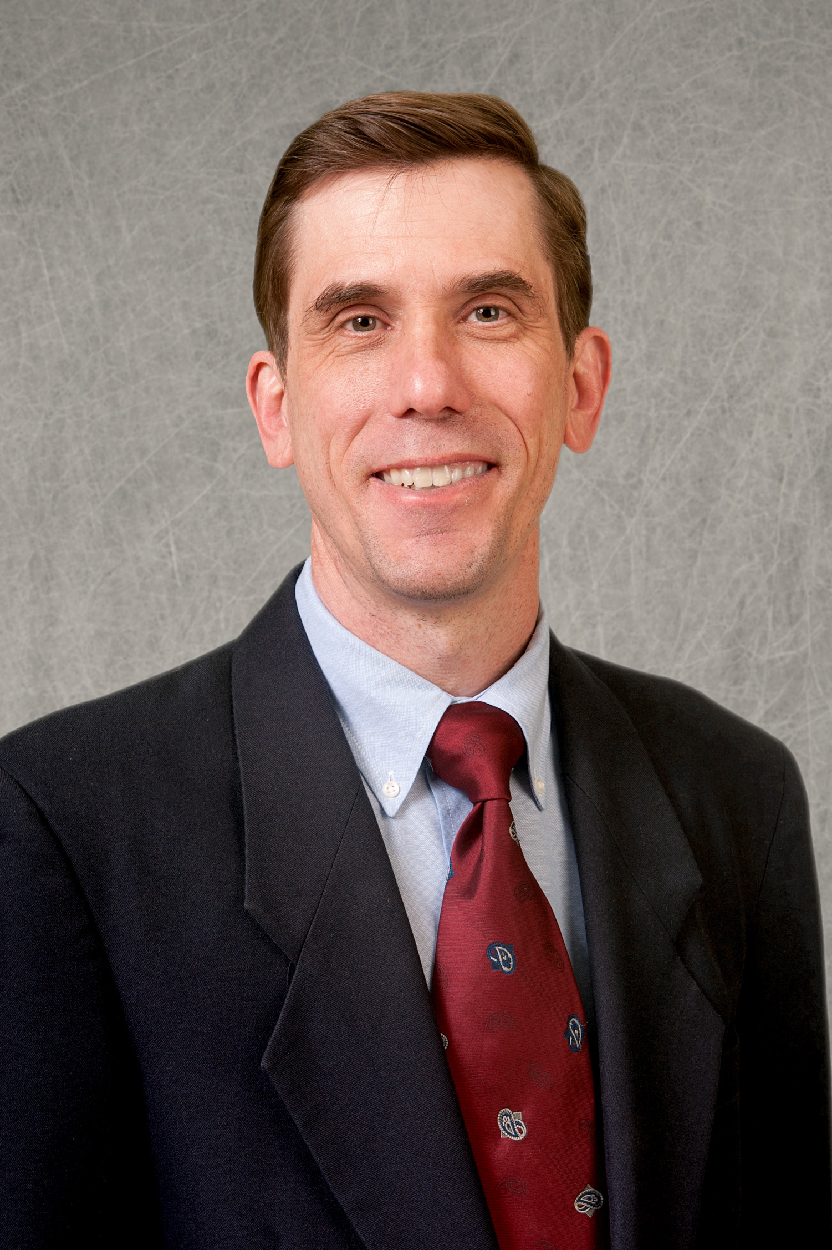
Fields of Activity
(1) Tuition of undergraduate students in the field of anatomy (English parallel classes). Leads practical classes, dissection classes, and lectures in new trends in experimental and clinical anatomy.
(2) Specializes in the research of mesodermal stem cells of the avian embryo following transplantation of the chicken fetus.
Publications & Output
Zhang N, Mustin D, Reardon W, Almeida AD, Mozdziak P, Mrug M, Eisenberg LM, Sedmera D. Blood-borne stem cells differentiate into vascular and cardiac lineages during normal development. Stem Cells Dev 2006; 15: 17-28

