SCORE

Information for incoming students

Content:

Welcome |  | 2
Arriving and Departure |  | 3
 | Getting to the hostel | 5
Accommodation and Boarding |  | 6
Prague |  | 8
 | Projects | 8
 | Faculty | 9
 | Sightseeing | 9
 | Guides | 11
See you in Prague |  | 11
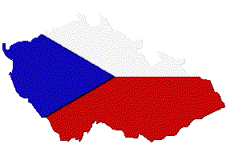
Welcome
I’m pleased to welcome you in Prague! Here are some basic information about Prague and Czech Republic
Situation of the CR : | In the centre of Europe
Borders with countries : | Germany, Austria, Slovakia, Poland
Area of the CR : | 78 866 square km
Population of the CR : | 10,28 million inhabitants
Location of Prague : | In the centre of Czech Republic, at 50°05”N and 14°27”E
Area of Prague : | 496 square km
Population of Prague : | 1,21 million inhabitants
Executive language : | Czech language
Currency : | Czech crown – 3zech symbol “Kc”, international symbol “CZK”
 | 1 Kc = 100 groat, 3zech symbol “h”
 | Coins: 50h and 1, 2, 5, 10, 20, 50 Kc
 | Banknotes: 20, 50, 100, 200, 500, 1000, 2000, 5000 Kc
 | Exchange rates
Time zone : | Central European time zone – GMT+1, in summer – GMT+2
Elevation of Prague : | 180 – 400 m above sea level
Climate : | Mild continental climate
Traffic in Prague : | Tram, bus, car, metro, taxi
Electrical Voltage : | Voltage 230 V – 50/60 Hz
Important tel. numbers : | Fire: 150
 | Ambulance: 155
 | Police: 158
 | City Police: 156
 | Road assistance: 1230
 | Gas emergency: 1239

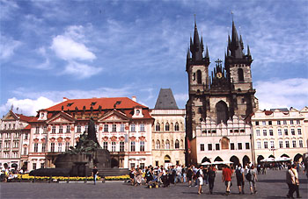
Arrival and Departure
Traveling by plane
The modern city airport, Ruzyně, is situated about 20 km northwest of the city centre. There are direct flights from most major European cities.
Facilities in the main building include a 24-hour money exchange office, a few ATMs, fast food places, several travel and accommodation agencies, rental car companies, a post office. There is also a 24-hour left luggage service in the Arrival Hall (the charge is about 40 Kč per piece of luggage).
Getting to the city centre:
Timetables are available at the airport information office in the main hall.
Bus & Underground
Catch a bus No 119 or No 254 from the airport to Dejvická metro station, and then follow a green line (A) of underground railway to the centre (stations Můstek or Muzeum). The trip takes about 45 minutes.
Bus & Tram
Bus No 100 will take you from the airport to Zličín the underground terminal stop of the yellow line (B) that leads to the town centre (Můstek station).
Catch night bus No 510 (between midnight and 3.30) to the tram-bound at Divoká Šárka, and then go by tram No 51 to Dejvická metro station or further to the city centre (Náměstí Republiky, Wenceslas Square).
Minibus
There are vans operated by Cedaz running from the airport (6 am – 9 pm) to Náměstí Republiky every 30 minutes for 90 Kč per person. Departure from Náměstí Republiky is between 5.30 am and 9.30 pm. Transport to any place of customer’s wish within Prague is also possible: for 360 Kč (1-4 persons), 720 Kč (5 and more persons).
Taxi
Depending on the destination, a trip to the city costs up to 700 Kč per 2-3 persons Before entering the car check the price with the driver. It is not recommended to except a price over 700 Kč.
Traveling by train
Domestic services are provided by ČD (Czech Railways). There are number of daily connections to Prague from major European cities.
Train Stations: Hlavní nádraží is the biggest and busiest railway station in Prague. There are a 24 hour left-luggage service, food stalls, information and booking offices.
Other train stations in Prague: Masarykovo nádraží, Holešovice Station, Smíchov Station
A supplement for fast express trains (rychlík) has to be paid. It is possible to buy plain tickets (jízdenka) or tickets with reservation (místenka) for a seat, couchette or sleeper.
It is necessary to make a reservation on the train marked with boxed or circled R, an R without a box means a reservation is recommended.
Information on rail connections are available on Tel: 02 / 242 242 00 or online www.cdrail.cz
Traveling by car
People, older than 18, are allowed to drive a car in the Czech Republic. Wearing a seatbelt is compulsory; children under the age of 12 have to sit at the back. After a consumption of any alcohol driving is illegal.
Most foreign driving licenses are honored; Australian and New Zealand drivers should get an International Driving License.
If entering the Czech Republic by car you will need:
• a valid driving license
• a vehicle registration card
• a hire certification
• Green Card (an international motoring certificate for insurance)
• a highway sticker (can be purchased at the border).
Other items you will have to carry at all times are: a first-aid kit, a set of replacement bulbs, a spare tire, and red warning triangles.
The speed limit is:
• 130 km/h (81 mph) on motorways
• 90 km/h (56 mph) on dual and single carriageways
• 50 km/h (31 mph) in urban areas.
Relaying on car in Prague is not advisable, as it is very difficult to find a suitable parking place and break-ins are very common. Only residents having a parking card can park their cars in the central area of Prague. If you happen to visit Prague by car, the best places to leave your car are guarded parking lots, especially the underground ones. New or expensive cars are vulnerable to break-ins, so do not leave anything valuable inside the car visible from outside, including car radios. They get stolen quite often.
Traveling by coach
The city main bus terminal is Florenc situated on the eastern edge of the New Town easily accessible by tube (yellow line B and red line C) and trams. The majority of internal coaches are run by ČSAD. Information on bus connection is available on www.jizdnirady.cz
Numerous international coach services are run by Bohemia Euroexpress International (Křižíkova 4-6, Prague 8 – Florenc, Tel: 02 24814450, 24218680, www.bei.cz).
Generally, coach travel is cheap but long distance traveling can be uncomfortable and slower than going by train or plane.
To make sure you get a seat it is advisable to obtain your tickets in advance.
Travel Documents and Customs
A valid passport is a necessity when entering the Czech Republic. To confirm visa requirements you are advised to contact the Czech embassy or consulate before traveling.
Customs allowances per person are 2l of wine, 1l spirits, 200 cigarettes (100 cigarillos, 50 cigars, 250g of tobacco) and goods up to the value of 6 000 Kč for a person at the age over 15 (3000 Kč for a person at the age up to 15).

Getting to the hostel:

Airport
Catch a bus No 179 from the airport to Nad Markétou bus stop

Railway Station (Hlavní nádraží)
Catch a tram No 9(direction to Sídliště Řepy) to Motol tram stop. From there catch a bus No 184(direction to Petřiny) to Nad Markétou bus stop

Bus Station (Florenc)
Take a metro line B (yellow) (direction to Zličín) to Nové Butovice metro station. From there catch a bus No.179 or No.184 (direction to Petřiny) to Nad Markétou bus stop

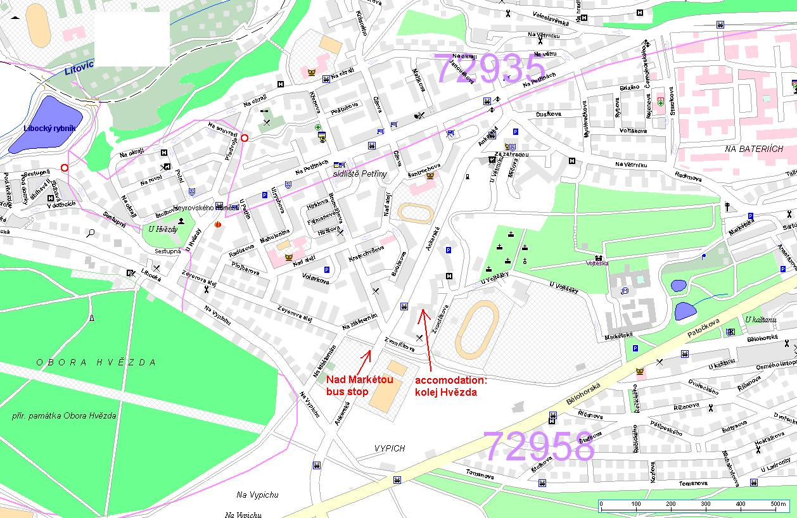
Břevnovský klášter  Located 5 min from the hostel | 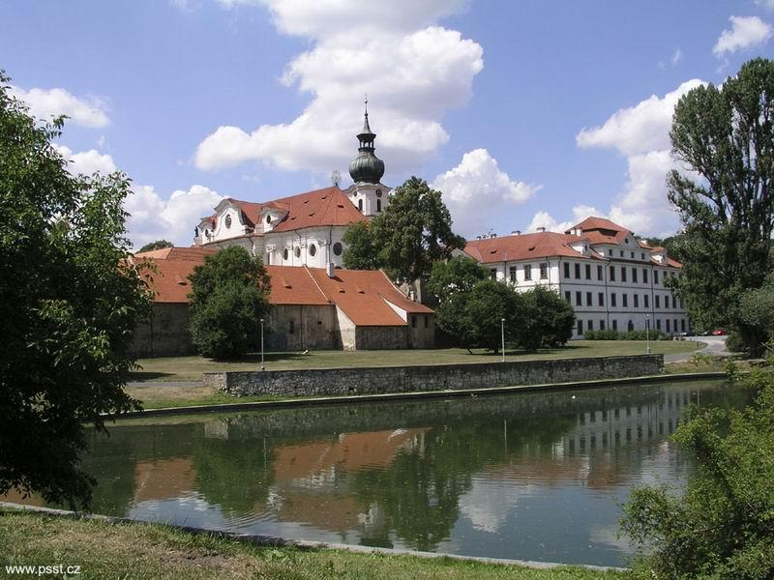
Accommodation and boarding

Kolej Hvězda
Address: | Kolej Hvězda  Zvoníčkova 5  162 08 Praha 6
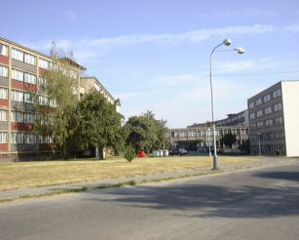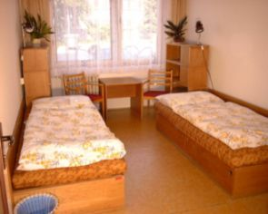
Some students might be allocated to a nearby hostel called Větrník (cca 5 min by walk)

Kolej Na Větrníku
Adresa: | Kolej Větrník  Na Větrníku 1932  162 00 Praha 6
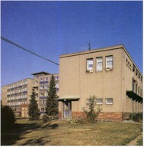
IFMSA CZ pays for you 30 nights. Extra nights are charged cca 100CZK = 3,3Euro. Food is not provided during summer months. Instead of food you will receive pocket money cca 2500CZK = 85Euro. Next to the hostel is located a nice restaurant with prices around 80CZK.

Czech national sign
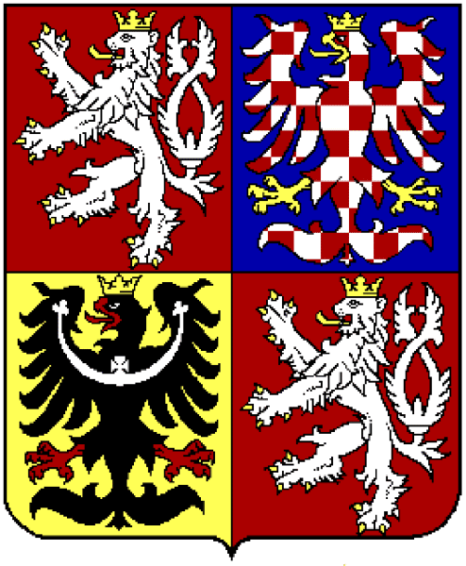
Prague

Projects
You have to attend the projects usually 4 days a week from 4-8 hours. Projects are located at the departments at the faculty place.
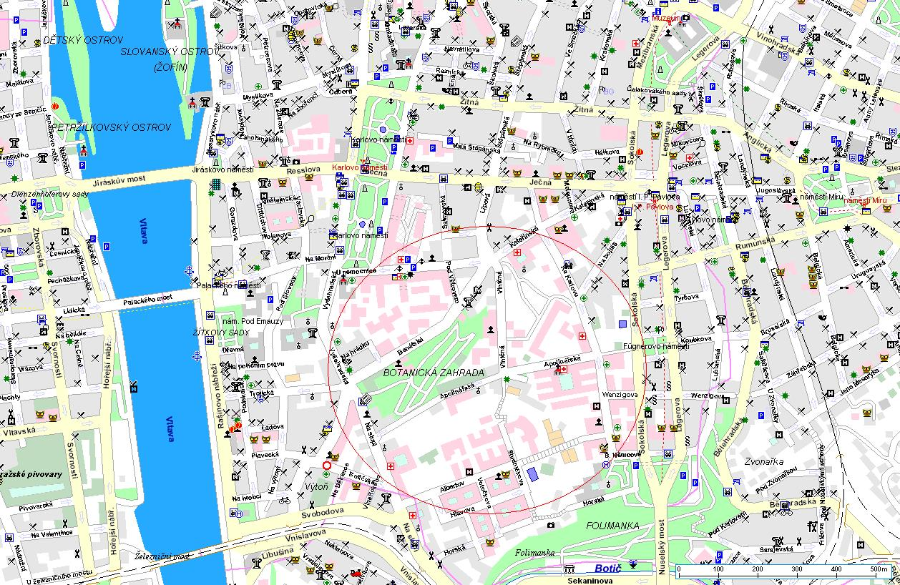

At first day of your exchange you will be told about the detail of the project by your tutor. You are asked to bring your own laboratory coat, white shoes and stethoscope:

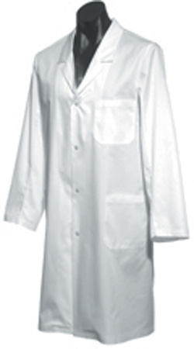 | 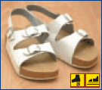 | 
Faculty
There is a possibility to visit library and internet at the faculty offices. You need ISIC to visit them. During your stay you will be part-time students of 1st Faculty of medicine.
Movie about 1st Faculty of Medicine
 |  | 

Sightseeing
Sightseeing in Prague – Click on picture
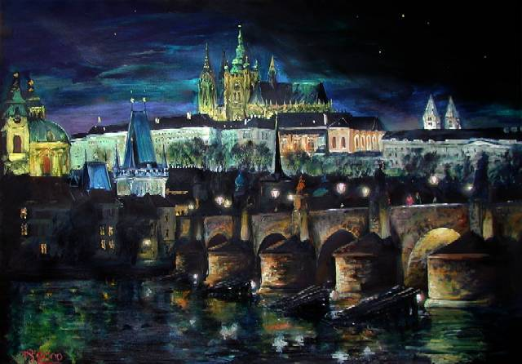
Visiting other cities
Český Krumlov
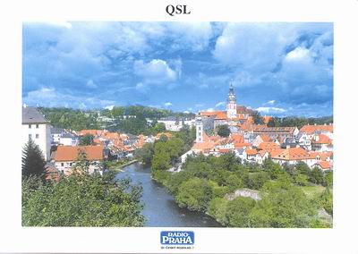
Karlovy Vary
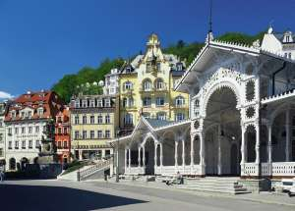
Karlštejn
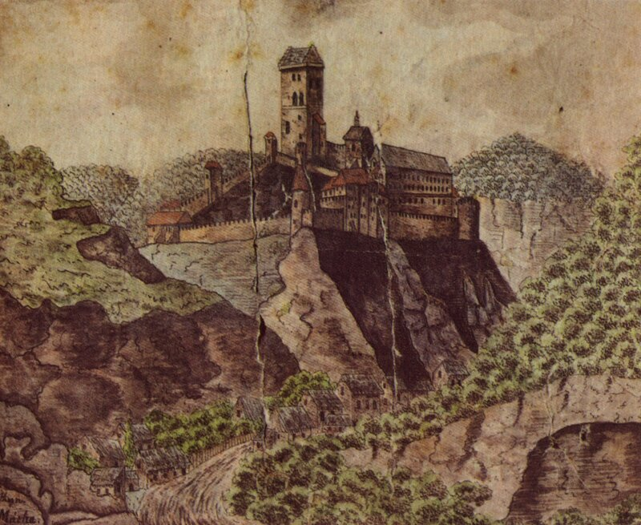
And many other places
Czech Tourism
Guides - Prague
Museums
Guide to Prague museums
Clubs and Bars
Guide to Prague clubs and nightlife
Culture
Guide to Prague music, theaters, opera and more

See you in Prague
- Don’t forget to bring camera
- Don’t forget to bring good mood
- Don’t forget to bring white coat, white shoes
- Don’t forget to bring some money for clubbing
- Don’t forget your health insurance!!!
- Check your flight ticket, passport and other documents!
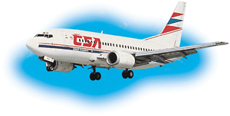

Jan Latta
LORE

