Publikování v časopisech MDPI:
1. Stručný úvod do publikační strategie vydavatelství MDPI

Is MDPI a predatory publisher?
Paolo Crosetto Uncategorized April 12, 2021 20 Minutes
https://paolocrosetto.wordpress.com/2021/04/12/is-mdpi-a-predatory-publisher/
This post is about MDPI, the Multidisciplinary Digital Publishing Institute, an Open-Access only scientific publisher.
The post aims to answer the question in the title: “Is MDPI a predatory publisher?” with some data I scraped from the MDPI website, and some personal opinions.
Main message
So, is MDPI predatory or not? I think it has elements of both. I would name their methods aggressive rent extracting, rather than predatory. And I also think that their current methods & growth rate are likely to make them shift towards more predatory over time.
MDPI publishes good papers in good journals, but it also employs some strategies that are proper to predatory publishers. I think that the success of MDPI in recent years is due to the creative combination of these two apparently contradicting strategy. One — the good journals with high quality — creates a rent that the other — spamming hundreds of colleagues to solicit papers, an astonishing increase in Special Issues, publishing papers as fast as possible — exploits. This strategy makes a lot of sense for MDPI, who shows strong growth rates and is en route to become the largest open access publisher in the world. But I don’t think it is a sustainable strategy. It suffers from basic collective action problems, that might deal a lot of damage to MDPI first, and, most importantly, to scientific publishing in general.
So that’s the punchline. Care to see where it stems from? In the following I will
- focus on the terms of the problem;
- develop an argument as to how the MDPI model works;
- try to give some elements as to why the model was so successful;
- explain why I think the model is not sustainable and is bound to get worse over time.
I’ll do so using some intuitions from social dilemmas and econ 101, a handful of personal ideas, and scraped data from MDPI’s website. The data cover the 74 MDPI journal that have an Impact Factor. They represent about 90% of all MDPI published articles in 2020 (somewhat less for the previous years, as MDPI growth has concentrated in their bigger journals. You find the data & scripts to reproduce the analysis in the dedicated github page.
Ready? Let’s go.
The problem
Scientists are by and large puzzled by MDPI.
On the one hand, MDPI publishes journals with high impact factor (18 journals have an IF higher than 4) many of which are indexed in Web of Science. Many, if not most papers are good. Several distinguished colleagues in nearly all fields served as Guest Editors or as Editors for their journals, often reporting positive assessments. MDPI is Open Access, so it does not contribute to the very lucrative rent-extraction at the base of Elsevier & other traditional publishers. MDPI’s editing is fast, reliable, professional; publication on the website is swift, efficient and smooth — all things that are hard to say of other, traditional, publishers. Several MDPI journals are included in the rankings used by different states to evaluate research and grant promotions to academics, for instance Sustainability is “classe A”, the highest possible rank, in Italy (source: ANVUR).
On the other hand, MDPI is known for aggressively spamming academics to edit special issues, often in fields that are far away from the expertise of the recipient of the frequent and insisting emails. Twitter is full of colleagues complaining that they get several invitations per week to contribute to journals they didn’t know existed and that lie outside of their domains, for instance here, here or here. MDPI even asked Jeffrey Beall, the author of Beall’s list of predatory publishers, to edit a Special Issue in a field that is not his own. It gets further than annoying emails, though. In 2018 the whole editorial board of Nutrients, one of the most prestigious MDPI journals, resigned en-masse lamenting pressures from the publisher to lower the quality bar and let in more papers.
This duality has generated some debates in several different places, among others in two posts by Dan Brockington here and here, in a post on the ideas4sustainability blog by Joern Fischer, and in the scholarly kitchen blog.
A predatory publisher is a journal that would publish anything — usually in return for money. MDPI rejection rates make this argument hard to sustain. Yet, MDPI is using some of the same techniques of predatory journals. So the question is simple: if you are a scientist, should you work with MDPI? Submit your paper? Review? (Guest) edit for them? Is MDPI predatory?
MDPI’s growth: how?
MDPI has had an impressive growth rate in the last years. It went from publishing 36 thousand articles in 2017 to 167 thousands in 2020. MDPI follows the APC publishing model, whereby accepted articles have to pay an Article Processing Charge (APC) before they are published. The APC has increased over time at MDPI. It can go up to more than 2000 CHF — MDPI is based in Switzerland — but there are several waivers and discounts. MDPI reports the average APC per article in 2020 amounted to 1180 €. Calculations by Dan Brockington show their revenue increasing from 14 mln $ in 2015 to 191 mln $ in 2020.
To know more about them, see their Annual Report 2020.
How did MDPI reach such high levels of growth? By cleverly exploiting the publish or perish policy widespread in academia, the fact that several countries mandate or suggest Open Access publications, and the rise of formal requirements for tenure and promotion within academia. But this state of affairs is independent of MDPI and anyone could have profited from it, though didn’t. So how?
As far as I can see, the success of MDPI relies on two key pillars: a lot of special issues and a very fast turnaround.
An explosion of Special Issues
Traditional journals have a fixed number of issues per year — say, 12 — and then a low to very low number of special issues, that can cover a particular topic, celebrate the work of an important scholar, or collect papers from conferences. MDPI journals tend to follow the same model, only that the number of special issues has increased in time, to the point of equaling, surpassing, and finally dwarfing the number of normal issues. Moreover, special issues are usually proposed by a group of scientists to the editors of the journal, who accept or reject the offer. At MDPI, it is the publisher who sends out invitations for Special Issue, and it is unclear which role, if any, the editorial board of the normal issues has in the process.
Virtually all of MDPI’s growth in the last years can be traced back to Special Issues.
The figure below shows the growth in articles for 74 journals with an IF at MDPI, dividing them between articles published in normal issues, special issues, collections and sections. Sections are a way to create several distinct branches of a single journal. Collections seem more similar to special issues, since they have their own collection editor. Special issues covered already the majority of papers in 2017 (it was not so earlier on, but I have article data from 2017 only), but grew rapidly from then on. While the number of normal issue articles increased 2.6 times between 2016 and 2020, the number of SI articles increased 7.5 times. At the same time, the number of articles in Sections increased 9.6 times, while Collections increased by 1.4 times. Articles in SI now account for 68.3% of all articles published in these 74 journals.
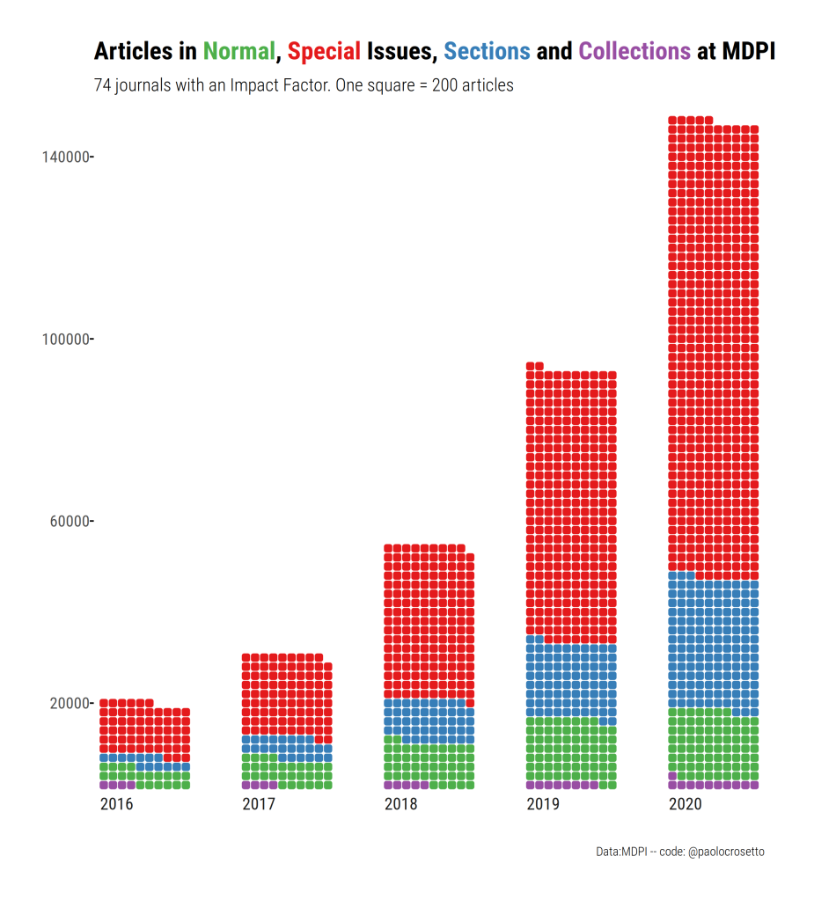
MDPI journals are becoming more differentiated, through the use of Sections, and they rely more and more on special issues.
The explosive SI growth is reflected also in the number of special issues, overall (table) and by journal (figure).
2013 | 2014 | 2015 | 2016 | 2017 | 2018 | 2019 | 2020 | 2021*
388 | 475 | 710 | 990 | 1386 | 2342 | 4096 | 6756 | 39587
Number of Special Issues at 74 MDPI journals with an IF. *open special issues with a closing date in 2021
Across the 74 journals, there were 388 Special Issues in 2013, about five per journal. In 2020, there were 6756 SIs, somewhat less than a hundred per journal. The provisional data for march 2021 counts 39687 SIs that are open and awaiting papers — about 500 per journal. Not all of them will go through — many will fail to attract papers, others will be abandoned by the Guest Editors — but in all likelihood SIs in 2021 will be much more numerous than in 2020.
SIs increase at all journals, in some cases exponentially. Some have unbelievably high number of SIs. In March 2021, Sustainability had 3303 open Special Issues (compared to 24 normal issues). These are 9 SIs per day, just for Sustainability. 32 MDPI journals have more than 1 open SI in 2021 per day, including Saturday and Sundays.
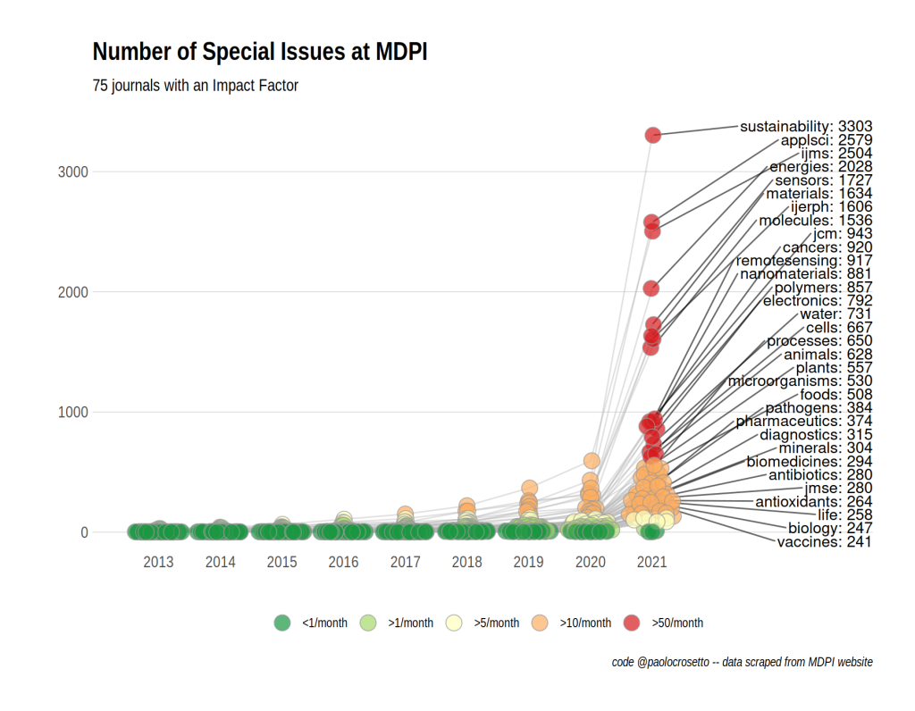
The “Journal Growth” table in the data appendix at the end of this post reports the growth of articles and number of SIs for each MDPI journal that published at least 100 articles in 2020. It also shows the share of articles that appear in SI rather than in the normal issues. This share has followed different paths in different journals, mainly because of the rise of Sections and Collections, but is still very high for virtually all journals.

2. MDPI a event. stanovisko fakulty
Časopisy skupiny MDPI mají mnohdy vysoké impakt faktory (např. prvokvartilové časopisy dle WoS: Cancers, Biomolecules, International Journal of Molecular Sciences), MDPI není t.č. na seznamu predátorských časopisů, ale analýzy uvedené na přiloženém odkazu zmiňují možné "predátorské rysy", ať už se jedná o agresivní marketing či vysoké počty vydávaných titulů.
Proti event. „zákazu / nedoporučení“ stojí názor ponechat vývoj "trhu" s tím, že pokud se budou časopisy chovat predátorsky, kvalita článků v nich logicky poklesne a následovat bude i pokles impakt faktoru a dalších bioliometrických parametrů. Další podstatné argument jsou, na základě čeho by se publikace neuznávaly, zda je to vůbec právně možné a pokud ano, jaké další kroky by měly být podniknuty (např. v součinnosti s centrálními knihovnami atd.).
Případný zákaz, nedoporučení či ponechání věci bez komentáře se dle mého názoru musí odvíjet od jasných a nezpochybnitelných informací, protože případný zákaz publikování v MDPI bude mít tvrdý dopad na všechny aspekty vědecké práce, včetně hodnocení publikačního výkonu, započítávání publikací do grantů, PhD studia, habilitačního a jmenovacího řízení atd. atd.
Zároveň musí mít členové vědecké obce jistotu, že jejich práce odeslaná do časopisů MDPI se po všech strastech spojených s publikačním procesem nakonec neobrátí proti nim, případně, že jim nezničí kariéru...jedná se o velice důležité a nelehké téma.

Scientometrické porovnání „tradičních“ časopisů a vybraných časopisů MDPI:
Tradiční časopisy:
Molecular Cancer Therapeutics (IF= 6.261, Q1 in Oncology, normalized Eigenfactor 5, AIS 1.811)
Frontiers in Oncology (IF= 6.244, Q2 in Oncology (ale je na pomezí, vloni byl Q1, letos o jedno pořadí Q2), normalized Eigenfactor 8.44, AIS 1.352)
MDPI:
Cancers (IF 6.639, Q1 in Oncology, normalized Eigenfactor 8.35, AIS= 1.319)
International Journal of Molecular Sciences (IF=5,923, Q1 in Biochemistry and Molecular Biology, normalized Eigenfactor 40, AIS= 1.123)

Současný pohled na MDPI:
1. Vyjádření Milana Janíčka z Ústřední knihovny UK:
Dodal bych ještě, že MDPI se celkem diskutuje i mezi knihovníky, ale kromě toho, že umně využívají aktuální systém financování se tak úplně nedaří je "nachytat" na nějakém jednoznačném porušení pravidel (třeba peer-review je rychlé, ale běží). Kvalita časopisů je různá v různých oborech. Podobné trendy velkého nárůstu publikací v MDPI ale vidí třeba i na našich partnerských univerzitách 4EU+, není to je záležitost ČR. A podobně roste třeba publikační aktivita ve Frontiers. To nedoporučení ze strany 2.LF je jedním z více, podobné třeba ještě vydala Slovenská ekonomická společnost (https://www.slovakecon.sk/files/TS_DORA.pdf). V tuhle chvíli to vypadá (alespoň to tak vnímám já), že časopisy od MDPI se nepovažují za top časopisy a pokud by člověk publikoval jen u MDPI, bylo by to dost nešťastné. MDPI ale také neznámená, že by šlo o nějaký článek v predátorském časopise. Pokud byste měli s MDPI konkrétní negativní nebo i pozitivní zkušenosti, budeme rádi za sdílení.
2. oficiální stanovisko Centra pro podporu open science na UK:
Co se týče vydavatelství MDPI, máte pravdu, že se objevilo na Beallově seznamu predátorských časopisů. Vzhledem k tomu, že toto vydavatelství má široké portfolio časopisů, je potřeba každý časopis posuzovat jednotlivě podle formálních kritérií. Vydavatelství MDPI je často kritizováno za vysoký počet publikovaných článků. Centrum pro podporu open science tuto kritiku bere v potaz, ale dle našich dosavadních analýz se tento růst publikací děje kvůli časově efektivnímu recenznímu řízení. Je pravda, že krátké recenzní řízení je často známkou predátorského časopisu, ale v případě MDPI není až podezřele nereálně krátké. Dle našich analýz je recenzní řízení často krátké proto, že vydavatelství má mnoho recenzentů a proto se recenzní řízení neprodlužuje právě výběrem a kontaktováním recenzentů. Závěrem, vydavatelství MDPI jako celek nelze označit za predátora, ale vědcům doporučujeme jednotlivé časopisy před publikováním raději ověřit. A proto je sleva, která je uvedena na webu Centra pro podporu open science, stále aktuální.

3. Stanovisko prof. Kašpárka, proděkana pro vědu LF MUNI:
…na LF MU se k ničemu podobnému (zákazu publikování v MDPI) nechystáme. Argumenty jsou v zásadě totožné s těmi, co uvádíte.

Odkazy na stránky:
https://paolocrosetto.wordpress.com/2021/04/12/is-mdpi-a-predatory-publisher/
https://www.lf2.cuni.cz/fakulta/clanky/prohlaseni-nazory-eseje/pozor-na-casopisy-vydavatelstvi-mdpi
http://metodikahodnoceni.blogspot.com/2021/08/sustainability-to-neni-lecjaky-casopis.html
https://www.slovakecon.sk/files/TS_DORA.pdf

